EXPERIMENT 2
Student Name: Jatin Tasoria UID: 25MCC20054
Branch: MCA-Cloud Computing Section/Group: MCC 101-A
Semester: 2nd Date of Performance: 21/01/26
Subject Name: Technical Training-I Subject Code: 25CAP-652

- Aim
The aim of this practical session is to implement SQL SELECT queries in PostgreSQL using filtering, sorting, grouping, and aggregation concepts to understand efficient data retrieval and analytical reporting.

- Objective:
After completing this practical, the learner will be able to:
- Retrieve required data using filtering conditions
- Sort query results using ORDER BY
- Perform aggregation using GROUP BY
- Apply conditions on aggregated data using HAVING
- Understand real-world analytical SQL queries

- Practical / Experiment Steps
  - Create a database and table in PostgreSQL
  - Insert sample records into the table
  - Apply filtering conditions using WHERE
  - Sort data using ORDER BY
  - Group records using GROUP BY
  - Apply conditions on grouped data using HAVING

- Procedure of the Practical
- Start the system and log in
- Start the PostgreSQL service
- Open PostgreSQL client (psql / pgAdmin)
- Create a new database
- Create the required table
- Insert sample records
- Execute SELECT queries for filtering, sorting, and grouping
- Verify query execution without focusing on output
- Save the work for documentation

- SQL Queries Used in the Experiment
  - Database Creation
CREATE DATABASE order_management;

  - Table Creation
CREATE TABLE orders (
order_id SERIAL PRIMARY KEY,
customer_name VARCHAR(50),
product_name VARCHAR(50),
quantity INT,
price NUMERIC(10,2), order_date DATE);
  - Inserting Sample Records
INSERT INTO orders (customer_name, product_name, quantity, price, order_date) VALUES
('Amit', 'Laptop', 1, 55000, '2024-01-10'),
('Neha', 'Mobile', 2, 30000, '2024-01-12'),
('Rahul', 'Laptop', 1, 60000, '2024-01-15'),
('Sneha', 'Tablet', 3, 15000, '2024-01-18'),
('Karan', 'Mobile', 1, 28000, '2024-01-20');

  - Filtering Data (WHERE Clause)
SELECT customer_name, product_name, price
FROM orders WHERE price > 30000;

  - Sorting Data (ORDER BY Clause)
SELECT customer_name, product_name, price
FROM orders
ORDER BY price DESC;

  - Sorting Using Multiple Columns
SELECT customer_name, product_name, price
FROM orders
ORDER BY product_name ASC, price DESC;

  - Grouping and Aggregation (GROUP BY)
SELECT product_name, SUM(price) AS total_sales
FROM orders
GROUP BY product_name;

  - Applying Condition on Aggregated Data (HAVING)
SELECT product_name, SUM(price) AS total_sales
FROM orders
GROUP BY product_name
HAVING SUM(price) > 50000;

- Input / Output Analysis (I/O Analysis)
SQL queries for:
- Table creation
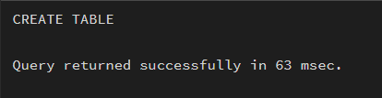

- Data insertion
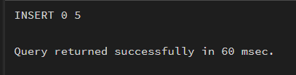
- Filtering
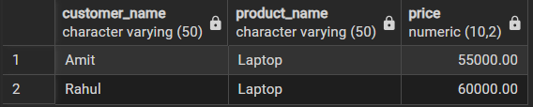
- Sorting
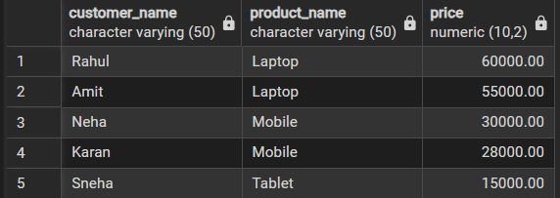
- Grouping
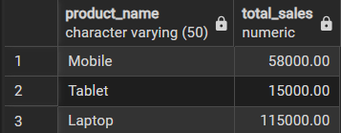
- Aggregation
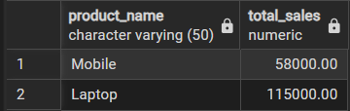

- Learning Outcome
Concepts Understood:
- Filtering using WHERE
- Sorting using ORDER BY
- Grouping and aggregation using GROUP BY and HAVING
Skills Developed:
- Writing structured PostgreSQL queries
- Designing analytical SQL statements
- Understanding query execution flow
Practical Exposure Gained:
- Hands-on experience with PostgreSQL
- Exposure to interview-oriented SQL queries

